APPLICATION FOR PARTICIPATION

PROFICIENCY TESTING № PTS 23/01

1. Information about the applicant

Name of the laboratory:

Certificate of accreditation:
(optional)

Manager:

Contact person:

Telephone:

E-mail:

2. Information about the participation

Test subject | Code of the standard | Tested parameters | Participation |  | Number of participations  (samples)
 |  |  | YES | NO
Hardened concrete  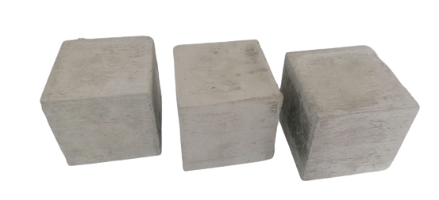 | *EN 12390-3 | Compressive strength
 | *EN 12390-7 | Density
*All tests will be carried out according to the last valid versions of the pointed standards!

Note: The product and the parameters are under the scope of accreditation of PT Provider PTS Bulgaria at PTS Bulgaria Ltd.

3. Information about the obtaining of the subjects of testing

Address:
4. Invoice data

Name of the organization:
Tax Identification Number (TIN):
Value Added Tax (VAT) Number:
Tax address (The address where the organization is registered):
Person in charge:

Contacts:
Eng. Valentin Belovski  Manager of  РТ Provider PTS Bulgaria  at PTS Bulgaria LTD |  |  | Eng. Atanas Atanasov  Quality manager of  РТ Provider PTS Bulgaria  at PTS Bulgaria LTD
 | +359 89 7503980 |  |  | +359 88 4027975
 | ptsolutionsbg@gmail.com  office@ptsbg.eu |  |  | ptsolutionsbg@gmail.com  office@ptsbg.eu

Date |  | Name, Surname

